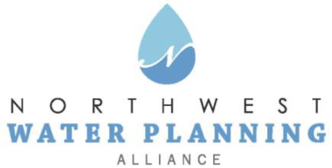

Technical Advisory Committee
October 26, 2021
10:00 am

In-person:  The Centre at Elgin (West Conference Room)  100 Symphony Way, Elgin | Online:  Register in advance  You will receive a confirmation email containing online meeting details

Agenda
- NWPA Welcome and Introductions

- Agenda Changes and Announcements

- Approval of September Meeting Minutes

- General Discussion on Current Water Topics in the NWPA Area – All

- Presentation: "Groundwater levels in McHenry County,” Judith Thomas, Groundwater and Geophysics Section Chief, USGS – Central Midwest

- Updates:
  - Sensible Salting Committee
  - CMAP
  - ISAWWA
  - MPC
  - ISWS
  - IDNR
  - USGS
  - Sugar Grove Water Authority

- Other Business
  - Pending Legislation and Regulations

- Next Meeting:
  - November 23, 2021: Join us for a presentation by Daniel Abrams, ISWS on sustainable yield estimates in northeastern Illinois.

