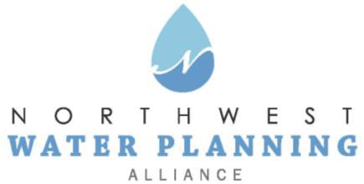

Technical Advisory Committee
May 23, 2023
10:00 am

Online:
Register in advance
You will receive a confirmation email containing online meeting details.

Agenda
- NWPA Welcome and Introductions

- Agenda Changes and Announcements

- Approval of April Meeting Minutes

- Presentations and facilitated exercises:
  - “Sustainability Goals for the NWPA Water Supply Sustainability Plan,” by Kelsey Pudlock, Chicago Metropolitan Agency for Planning (CMAP)
  - “NWPA Profile and Strategy Selection for the NWPA Water Supply Sustainability Plan,” by Kelsey Pudlock and Katie Piotrowska, CMAP, and Margaret Schneemann, Illinois Indiana Sea Grant

- Updates:
  - Sensible Salting Committee
  - CMAP
  - ISAWWA
  - ISWS
  - IDNR
  - USGS
  - Sugar Grove Water Authority

- Other Business
  - Pending Legislation and Regulations

- Next Meeting:
  - June 27, 2023

