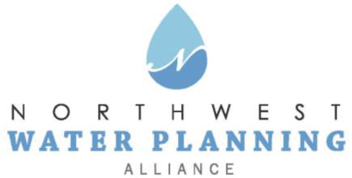

Technical Advisory Committee
June 27, 2023
10:00 am

Online:
Register in advance
You will receive a confirmation email containing online meeting details.

Agenda
- NWPA Welcome and Introductions

- Agenda Changes and Announcements

- Approval of May Meeting Minutes

- Presentations:
  - “Results from a Summer 2022 ISWS study of groundwater quality in Lake County’s shallow aquifer,” by Cecilia Cullen, Illinois State Water Survey (ISWS)
  - “NWPA Water Supply Sustainability Plan: Examining Conservation Strategies,” by Margaret Schneemann, Illinois Indiana Sea Grant (IISG)

- Updates:
  - Sensible Salting Committee
  - CMAP
  - ISAWWA
  - ISWS
  - IDNR
  - USGS
  - Sugar Grove Water Authority

- Other Business
  - Pending Legislation and Regulations

- Next Meeting:
  - July 25, 2023

